

**A PROCEEDINGS REPORT FOR A MEDIA TRAINING FOR YOUTH GROUPS.**

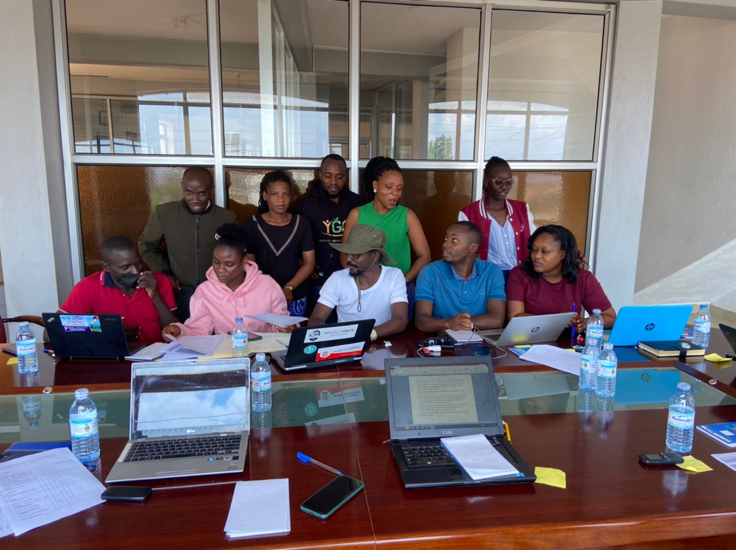

Group photo of participants

**March 11, 2023**

**Introduction**

On March 11, 2023, Youth For Environmental Justice and Climate Action (YECA) organised a media training for youth in Kampala.

To improve youth skills on use of media ,CERAIorganised a one day media training that brought together youth from different organisations to acquire skills on how to effectively used media to improve their advocacy.

The objective of the training was to equip youth with skills on how to use media to advocate for lower power tariffs to promote a just energy transition in Uganda.

The training was participated in by 10 participants from different organisations. Of the participants, five (5) were male while five (5) were female.

**2. Proceedings**

**2.1 Presentation from the trainer,**

M Robert the Communications Officer from CERAI welcomed participants to the training and informed them that this is an opportunity for them to learn how to use both media and social media platforms to advocate for low power tariffs in uganda. Later, Robert informed participants about her previous media trainings and experience and encouraged participants to pay attention in order not to miss out very important key points during media advocacy.

She then allowed members to introduce themselves and after the training session begun.

**2.2 Presentation from the trainer**

First and foremost, Robert welcomed participants and thanked them for turning up. She began asking participants about their level of knowledge on media, the media platforms they know and use and difficulties they have found while using media.

Thereafter, Robert said that the main objective of this session is to equip youth with knowledge on how to use media to improve their advocacy skills.

Robert said that many young people have failed in business sector not because they do not have skills but because they have failed to pay power bills. For example Robert Said that using media is a big opportunity for youth to inform the concerned authorities to reduce on tariffs and enable them to access power for them to succeed in business sector and other ventures.

Robert then took participants through the following sessions,

**What is media?**

Robert said these a medium of communication that a used by different channels to send out information.

What are examples of media channels?

* Print media (books, magazines, newspapers
* Televisions
* Movies
* Social media
* Phones and various forms of soft wares.

**1. Print media**

These include books, magazines, and newspaper opinion articles among others.

Robert said youth can write opinions on how high power tariffs have affected them and share with media houses for publishing.

Further, she said this is one of the ways to send out information that reached the target audience since almost everyone reads newspapers. She said research is key when writing these articles to avoid misinformation.

Robert shared tips of writing these articles and encouraged participants to at least write one article per month to keep the advocacy alive. She later shared different emails of different media platforms where they can send their articles for publication.

In addition, Robert shared merits of using opinions that includes,

* They offer the public space to air their views.
* Help to shape debate in society and focuses public at the center of discussion.
* They give room for the people to issue content in a biased but informative format.

**Press statement**

Robert said that this is an announcement that an organisation/company sends out to the media with the purpose of informing the public about a new developments.

She said press statement matter because of the following,

* A good way of making an official statement.
* It is cheaper to use a press statement than calling a press conference.
* Press statements help to guide rookie journalists where media houses are increasingly losing their best journalists.
* Limits the risks of having information distorted.

**Later, Robert shared ideas on how to write opinions that included,**

* Think of the idea and conceptualize it.
* Discuss the issues of why it matters. Signposts are usually the new debate around the new development.
* Mention who the winners and losers are.
* Paying off is simply finishing your pint with a strong argument.

**2. Social media**

This include wahtsapp, Facebook, twitter, tiktock and others .Robert said that these platforms should be used effectively. She encouraged participants to always post relevant information basing on the advocacy they are doing. She later supported those who had no twitter accounts to open through group discussions**.**

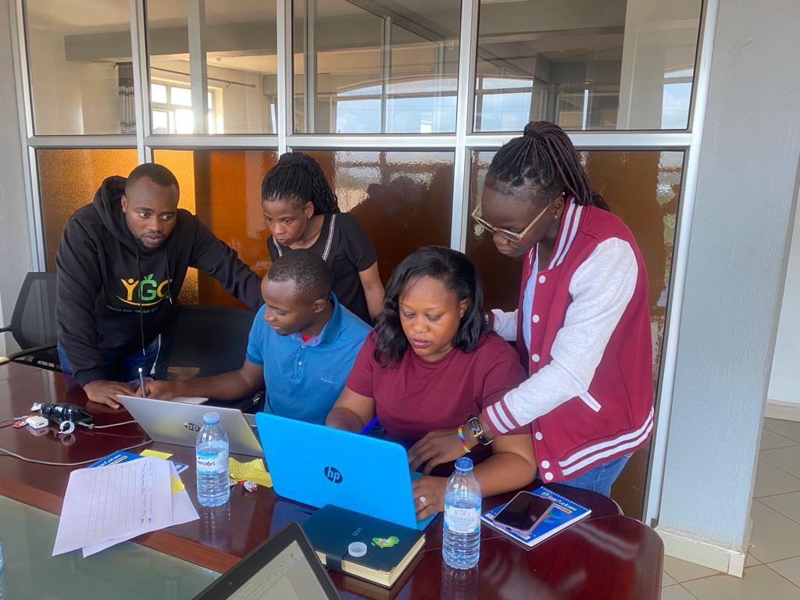

**Practical Group discussion**

**Common media styles**

The trainer further shared style of writing that participants should be used .She said that this eases work of editors to edit their stories and encouraged participants to take note of them**,**

* Clarity is key
* Keep it clear and avoid jargon
* Avoiding unwinding and unnecessary statements. Stick to the points and build on them.
* Be mindful of lawsuits for the media house.
* Keep a word count to 700 -750 words
* Timing matters
* Fairness

**3. Reactions**

The participants asked the media trainer some questions and she responded accordingly.

**Qn**: **Mr. Solomon Ainamani from YGC asked about if everything written is published .He shared an experience that previous he wrote an article and shared with new vison but up to now the article haven’t been published ,he asked why?**

Racheal informed participants that an opinion to be published, it has to be between 700-750 words. She further said that the article has to be on the current issues happening with evidence, as this will convince editors to publish it. Finally, Racheal said that it is not a must for every article to be published and encouraged members to keep trying and writing to increase chances of their opinions to be published.

**Qn: Vanesa from UCU asked about how to use media to advocate for lower power tariffs and energy transition?**

Robert responded that there a many ways, these include organizing social media compaigns, writing press statements and newspaper opinion articles to advocate for energy transition.

Thereafter, the training ended.

**4. List of Participants**

|  |  |  |  |  |  |
| --- | --- | --- | --- | --- | --- |
| **NO** | **NAME** | **SEX** | **AGE** | **INSTITUTION & POSITION** | **EMAIL /TEL** |
| 1 | Gumisiriza Modern | F | 18-35 | YNC | 0789215552 |
| 2 | Aryampa Brighton | M | 18-35 | YGC | 0784679759 |
| 3 | Nsiimire Hilda | M | 18-35 | Kyambogo university | 0704095189 |
| 4 | Edema Patrick | M | 18-35 | IGPU | 0703252154 |
| 5 | Kembabazi Barbra | F | 18-35 | IGEN -EA | 0784838965 |
| 6 | Amongin Racheal | M | 18-35 | FRA | 0756949678 |
| 7 | Tusingwire Comfort | M | 18-35 | AIFE | 0781527670 |
| 8 | Ainamani Solomon | M | 18-35 | Makerere university | 0789893507 |
| 9 | Nabachwa Vanesa | M | 18-35 | UCU | 0702677016 |
| 10 | Namara Doreen | F | 18-35 | Fridays for future | 0772010268 |

**END**